
Nile Valley Consistory of Ancient and Accepted Scottish Rite
Commander in Chief
ILL:. B:. Gerald Walker 33°
Deputy, Commander
ILL:. B:. Roderic DeSouza 33°
Officers to be commissioned
1st Lt. Commander
2nd Lt. Commander
Grand Orator
Grand Chancellor
Grand Master of Ceremonies
Grand Treasure
Grand Secretary
Grand Standard Bearer
Grand Hospitaller
Grand Architect & Engineer
Grand Captain of the Guard
Grand Tiler

Greetings Brothers,
This is a formal communication regarding Consistory meetings and annual dues. I must say we are off to a good start, and I am very pleased with your participation and enthusiasm thus far.
However, we still have brothers not showing up to our meetings or giving me a myriad of excuses for not attending the meetings, this has to stop! Meetings are published at least two weeks in advanced, and communicated to most of you thru texting, and phone calls. Do not call Brother Hazel with excuses as to why you did not make your meeting or pay your dues… he does not want to hear it! The buck stops with me, brothers I intend to dispatch my duties as “Commander – in – Chief” to the best of my abilities. As such, I must implement the following policies:
- Two missed meetings will automatically generate a warning letter of pending suspension from the house in question.
- Two missed dues payments will automatically generate a warning letter of pending suspension from the house in question.
I trust these policies will insure continued success with your masonic education and the growth of the Holy Empire!
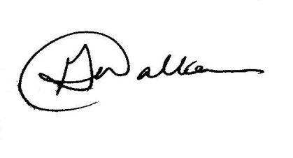
Fraternally,

Ill:. B:. Gerald Walker 33°
Commander in Chief

ILL:. B:. Clifford E. Hazel 33°/96°
The Most Puissant Sovereign Grand Commander

